**Getting Started**

**With Himax WE-I Plus**

**(Windows)**

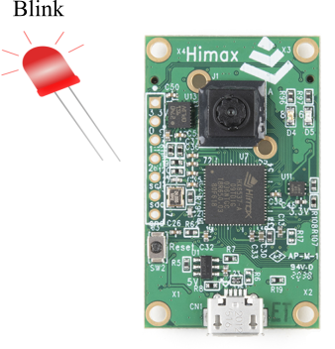

Muhammad Zeeshan

**Downloading and Installing Softwares**

To compile and upload the image file to the flash memory of our Himax Development board. We need some softwares and toolchain to accomplish this task. Here is the list of required softwares we need

1. ARC GNU Toolchain
2. Himax Image Generation Tool
3. Tera Term
4. ARC GNU Toolchain

The easiest way to install ARC GNU Toolchain is using the ARC GNU IDE. You just need to download EXE installer from [here](https://github.com/foss-for-synopsys-dwc-arc-processors/toolchain/releases). Currently I am using GNU Toolchain for ARC Processors, 2019.03 RC1. You can found this version on page 3. Scroll down to the page and you will find a download button.

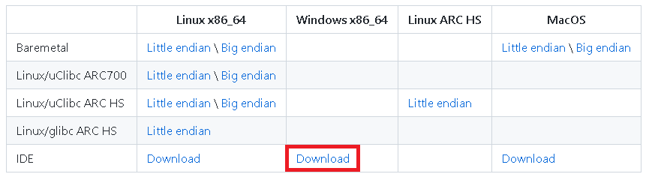

After downloading, install the IDE with default settings. Here are few images that shows the installation process.

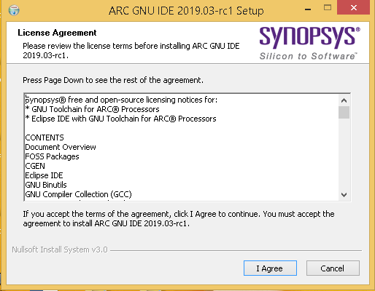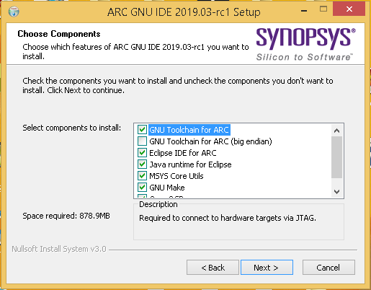

At the end close the installation window.

To confirm your Toolchain is installed and working. Open the Command Prompt and type **arc-elf32-gcc --version**. You will a similar output as shown here.

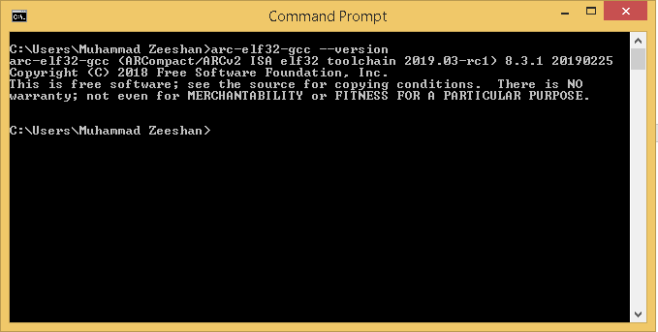

1. Himax Image Generation Tool

Himax Image Generation Tool is a command line software used to convert your compiled source code (.elf file) to an image file (.img). You can download Image Generation Tool from [here](https://github.com/HimaxWiseEyePlus/bsp_tflu). In this repository, there are a lot of examples projects, guide and tools. We just need Image Generation Tool found in [Image_gen_Tool_windows_version](https://github.com/HimaxWiseEyePlus/bsp_tflu/tree/master/Image_gen_Tool_windows_version) directory.

After downloading the repository, extract only the **image_gen_windows_v2_1_11** directory anywhere you want. I am extracting it to my C drive. We have to add this path to our makefile.

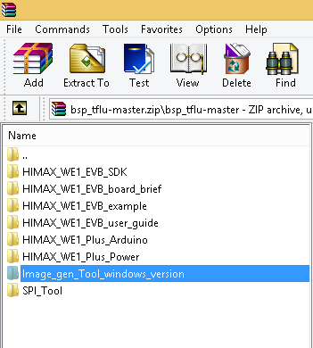 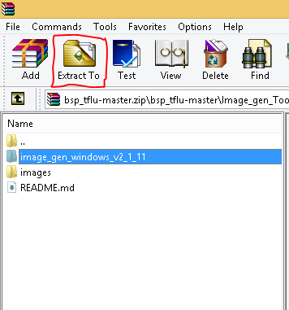

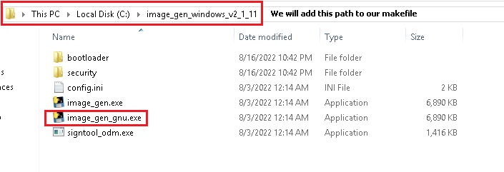

To make sure Image Generation Tool is working. Open the Command Prompt, change directory where you have extracted your Image Generation Tool and type **image_gen_gnu –h**. You will see all the available options to use this software.

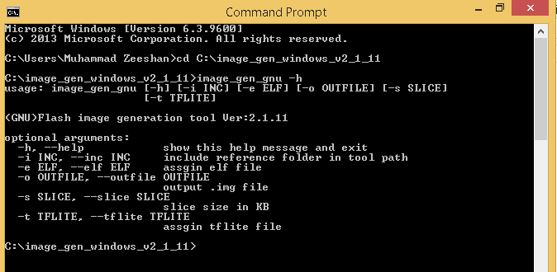

**Problem**: Image Generation Tool is not going to work with Windows Command Prompt. (This tool is not native windows executable but compiled with cygwin1.dll). It requires Cygwin terminal. You can download and install the Cygwin from [here](https://www.cygwin.com/setup-x86_64.exe).

Another solution is to add the cygwin1.dll file into the Image Generation Tool directory. And the tool will work with Windows Command Prompt. I have added this DLL file and this fixes the problem. See the image below.

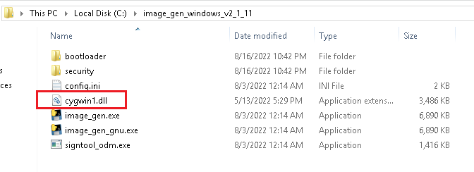

This modified version is available in my GitHub repository.

1. Tera Term

Here Tera Term is used to upload image files to our Himax WE-I Plus development board (using the XMODEM protocol). And later on we will use this to get the serial data from Himax WE-I Plus. Download the Tera Term software from [here](https://filehippo.com/download_tera-term/) and install it with the default settings.

**Example Project**

Before starting our Example Project i.e. blinking LED. Let’s take a look at Himax WE-I Plus Development Board first.

1. **Board Overview**

WE-I Plus is packed with a lot of features:

1. VGA Camera module
2. Two MEMS microphones
3. Onboard LEDs (Green and Red)
4. 3-axis Accelerometer
5. Two I2C Buses, one is used by the onboard Accelerometer and other can be used by our application.
6. Three GPIOs
7. One SPI port (available via micro USB)
8. One UART port (available via micro USB)

You can find more details at [Himax](https://www.himax.com.tw/products/intelligent-sensing/always-on-smart-sensing/developing-tools/)

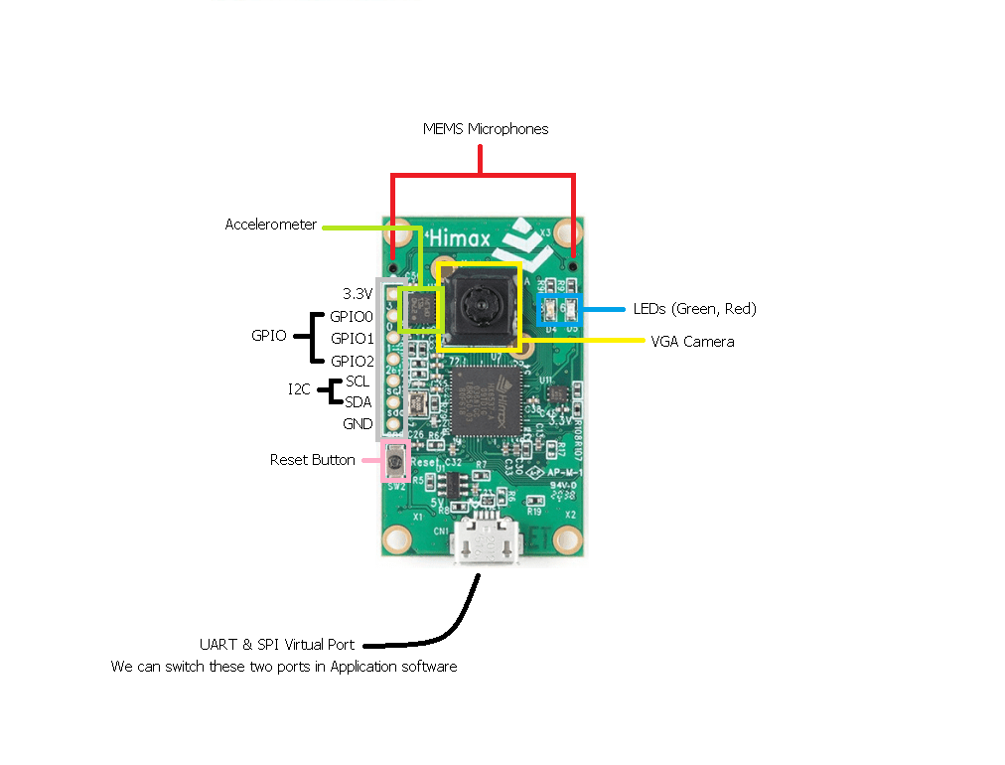

1. **Blinky Project**

To start a new project, use the Example project as starting point. Head to my GitHub repository (here) and download it. You will find this documentation, example project and Himax Image Generation Tool (I have added the cygwin1.dll).